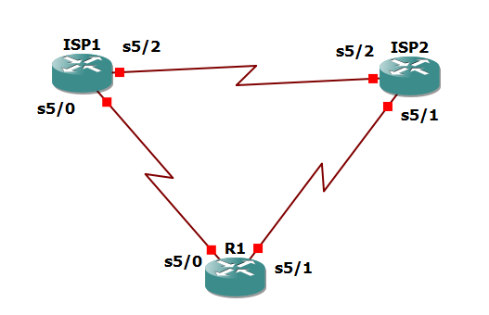

Router R1

config

hostname R1

interface Loopback 0

description R1 LAN

ip address 192.168.1.1 255.255.255.0

interface Serial5/0

description R1 --> ISP1

ip address 209.165.201.2 255.255.255.252

clock rate 128000

bandwidth 128

no shutdown

interface Serial5/1

description R1 --> ISP2

ip address 209.165.202.130 255.255.255.252

bandwidth 128

no shutdown

Router ISP1 (R2)

config

hostname ISP1

interface Loopback0

description Simulated Internet Web Server

ip address 209.165.200.254 255.255.255.255

interface Loopback1

description ISP1 DNS Server

ip address 209.165.201.30 255.255.255.255

interface Serial5/0

description ISP1 --> R1

ip address 209.165.201.1 255.255.255.252

bandwidth 128

no shutdown

interface Serial5/2

description ISP1 --> ISP2

ip address 209.165.200.225 255.255.255.252

clock rate 128000

bandwidth 128

no shutdown

Router ISP2 (R3)

config

hostname ISP2

interface Loopback0

description Simulated Internet Web Server

ip address 209.165.200.254 255.255.255.255

interface Loopback1

description ISP2 DNS Server

ip address 209.165.202.158 255.255.255.255

interface Serial5/1

description ISP2 --> R1

ip address 209.165.202.129 255.255.255.252

clock rate 128000

bandwidth 128

no shutdown

interface Serial5/2

description ISP2 --> ISP1

ip address 209.165.200.226 255.255.255.252

bandwidth 128

no shutdown

R1# show interfaces description | include up

R1(config)# ip route 0.0.0.0 0.0.0.0 209.165.201.1

ISP1(config)# router eigrp 1

network 209.165.200.224 0.0.0.3

network 209.165.201.0 0.0.0.31

no auto-summary

exit

ISP1(config)# router eigrp 1

ip route 192.168.1.0 255.255.255.0 209.165.201.2

ISP2(config)# router eigrp 1

network 209.165.200.224 0.0.0.3

network 209.165.202.128 0.0.0.31

no auto-summary

exit

ISP2(config)# ip route 192.168.1.0 255.255.255.0 209.165.202.130

R1#tclsh

foreach address {

209.165.200.254

209.165.201.30

209.165.202.158

} {

ping $address source 192.168.1.1

}

R1

foreach address {

209.165.200.254

209.165.201.30

209.165.202.158

} {

trace $address source 192.168.1.1

}

R1(config)# ip sla 11

icmp-echo 209.165.201.30

frequency 10

exit

R1(config)# ip sla schedule 11 life forever start-time now

R1# show ip sla configuration 11

R1# show ip sla statistics

R1(config)# ip sla 22

icmp-echo 209.165.202.158

frequency 10

exit

R1(config)# ip sla schedule 22 life forever start-time now

end

R1# show ip sla configuration 22

R1# show ip sla configuration 22

R1# show ip sla statistics 22

R1(config)# no ip route 0.0.0.0 0.0.0.0 209.165.201.1

ip route 0.0.0.0 0.0.0.0 209.165.201.1 5

exit

R1# show ip route | begin Gateway

R1(config)# track 1 ip sla 11 reachability

delay down 10 up 1

exit

R1# debug ip routing

R1(config)# ip route 0.0.0.0 0.0.0.0 209.165.201.1 2 track 1

R1(config)# track 2 ip sla 22 reachability

delay down 10 up 1

exit

R1(config)# ip route 0.0.0.0 0.0.0.0 209.165.202.129 3 track 2

R1#show ip route | begin Gateway

ISP1

config

interface serial5/0

ISP1(config-if)# int lo1

shutdown

R1# show ip route | begin Gateway

R1# show ip sla statistics

R1# trace 209.165.200.254 source 192.168.1.1

ISP1(config-if)# no shutdown

R1# show ip sla statistics

R1# show ip route | begin Gateway